**Google search**

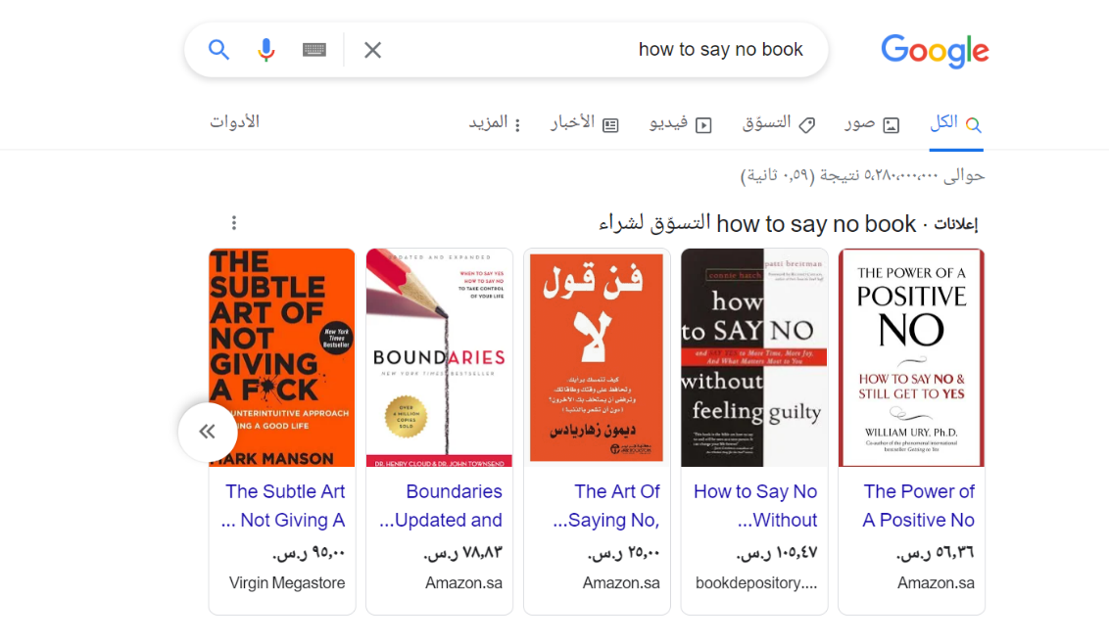

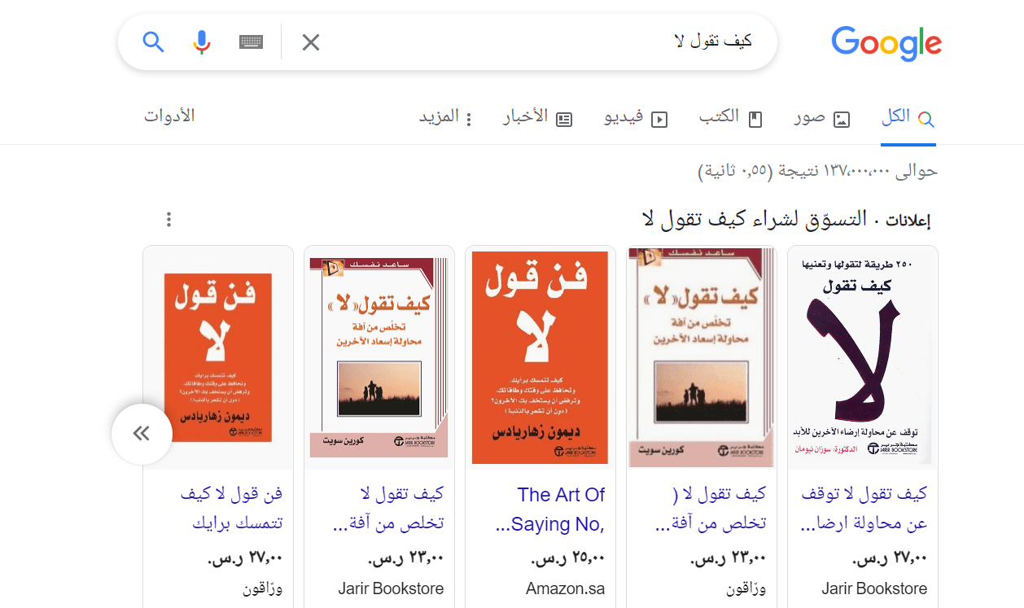

**Google and Bing Search**

When you search in Google in Arabic and English, the search results are the same, **but** Bing results are different and this is a bug.

**Bing search**

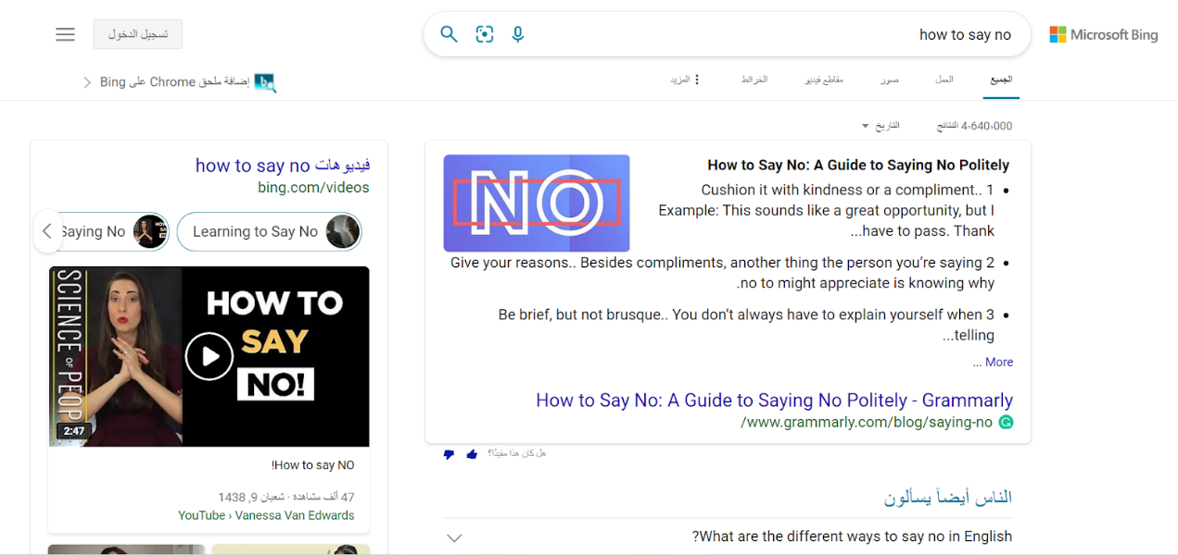

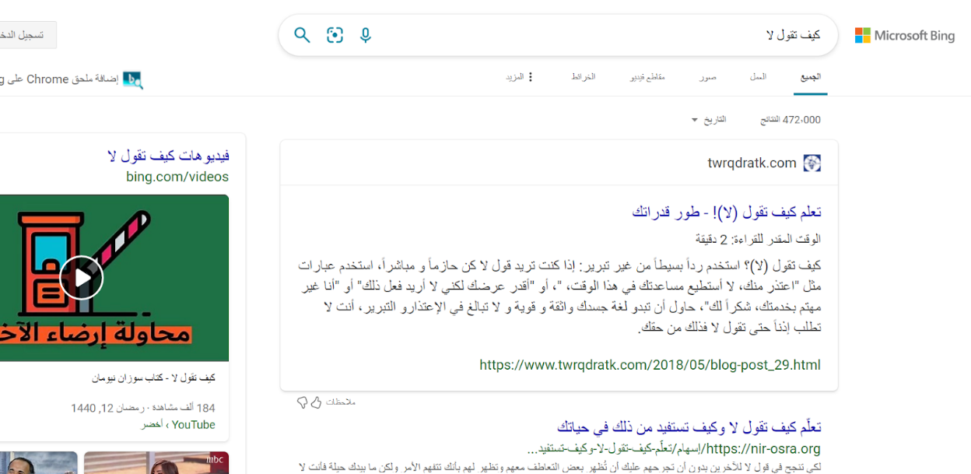

**Google and Bing Search**

When you search in Google in Arabic and English, the search results are the same, **but** Bing results are different and this is a bug.